**ABSTRACT**

The **ATM System** is the project which is used to access their bank accounts in order to make cash withdrawals. Whenever the user need to make cash withdraws, they can enter their PIN number (personal identification number) and it will display the amount to be withdrawn in the form of 100’s 500’s and 1000’s.

The ATM will service one customer at a time. A customer will be required to enter ATM Card number, personal identification number (PIN) – both of which will be sent to the database for validation as part of each transaction. The customer will then be able to perform one or more transactions. Also customer must be able to make a balance inquiry of any account linked to the card.

The ATM will communicate each transaction to the database and obtain verification that it was allowed by the database. In the case of a cash withdrawal, a second message will be sent after the transaction has been physically completed (cash dispensed or envelope accepted).  If the database determines that the customer’s PIN is invalid, the customer will be required to re-enter the PIN before a transaction can proceed.

If a transaction fails for any reason other than an invalid PIN, the ATM will display an explanation of the problem, and will then ask the customer whether he/she wants to do another transaction.

The ATM will provide the customer with a printed receipt for each successful transaction, showing the date, time, machine location, type of transaction, account(s), amount, and ending and available balance(s) of the affected account (“to” account for transfers)

**TABLE OF CONTENTS**

* **Introduction**
* **System Specification**
* **Project Description**
* **System Study & Analysis**
* **System Design**
* **UML Design**
* **Conclusion**

**INTRODUCTION**

Automated Teller Machine enables the clients of a bank to have access to their account without going to the bank. This is achieved only by development the application using online concepts.

When the product is implemented, the user who uses this product will be able to see all the information and services provided by the ATM, when he enters the necessary option and arguments. The product also provides services like request for cheques, deposit cash and other advanced requirement of the user. The data is stored in the database and is retrieved whenever necessary. The implementation needs ATM machine hardware to operate or similar simulated conditions can also be used to successfully use the developed product.

To develop this ATM system the entire operation has been divided into the following step:

1. verification process
2. language, service and account selection
3. Banking services
4. Transactions
5. Special services

The program is designed in such a way that the user has to card and pin number. Once verified, he is provided a menu and he/she had to enter the option provided in the menu. For example, when the user wants to view the list of payment history than he/she had to enter the option for payment history provided in the main menu. When the option is entered alone with the respective argument, then the payment history is displayed on the screen.

The user also must be given option to browse through the pages like previous page, next page, etc. The user may experience a delay in retrieving or viewing the data, when there are many users logged on to the same bank branch system.

Need for the ATM system:

Millions of times per day around the globe people are instantly withdrawing money at automatic teller machines (ATMs). Given the fast-pace of the world today, it is not surprising that the demand for access to quick cash is so immense. The power of ATMs would not be possible without secure connections. The final act of ATM dispending cash is the result of an amazingly fast burst of the customer never sees, but a trust is being done in a confidential manner.

**SYSTEM SPECIFICATION**

**Hardware Requirements:**

1. Processor                     – Pentium 4
2. RAM                           – 1 GB
3. Hard Disk                    – 40GB
4. Mouse                          – Standard Mouse
5. Keyboard                     – Logitech Keyboard
6. Processor Speed          – 2.4GHZ

Software Requirements:

1. Operating System                     – Microsoft Windows XP With Service Pack 2
2. Front-End                                – Microsoft Visual Studio 2005
3. Back-End                                 – Microsoft Access 2003

Display Mode:

1. Color Quality – Highest[32 bit]

2. Screen Resolution – 1024 by 768 Pixels.

**PROJECT DESCRIPTION**

Need For The Software:

Now a days every one very busy in their work. So they feel that the job must be easier so the system is used to reduce their work which is done in the ATM system. Instead of keeping lots of paper into a record or file and it may be missed somewhere so, this system help to keep the record of the customer it also keeps the details of he customer. It is also easy to access.

Problem description :

The system mainly used by the bank clients. When a client comes to ATM centre to update and delete their account. It reduces the time consumption and lot of paperwork. For any single operation it involves numerous references and updating also takes subsequent changes in other places.

**SYSTEM STUDY AND ANALYSIS**

Existing System:

• The existing system is manual system.

• The manual system is prone to error.

• This system involves a lot of manual entries with the application to perform a desired task.

• Usage of papers and records in the process leads to less efficiently less productivity.

• Increase lots of mistakes while writing in paper.

• Time delay between the user and customer is reduced.

• For this reason the new system in invented.

Proposed System:

The system customer transactions, satisfies the requirements of the existing system in full-fledged manner. Through this system, customer can make fast transactions and view the last transactions easily.

System Analysis:

Understand the problem before the system to create analysis model there is a tendency to rush to a solution, even before the problem is understood.

Develop prototypes that enables user to understand how human/machine interaction will occur. Since the perception of the quality of software is often based on the perception of the “friendliness” of the interface prototyping is highly recommended.

Record the origin of and the reason for every requirement. This is the first step-in establishing traceability back to the customer.

Use multiple views of requirements building data, functional and behavioral models provide the software engineer with three different views. This reduces the likelihood that something will be missed and increases the likelihood that inconsistency will be recognized.

Rank requirements. Tight deadlines may preclude the implementation of every software requirements to be delivered in the first increment must be identified.

Work to eliminate ambiguity because most requirements are described in a natural language, the opportunity for ambiguity abounds.

**System planning:**

• Analysis principles are applied and a model of the software to be build called a planning (prototype) is constructed for customer and developer assessment.

• The close-ended approach is often called throwaway prototyping using this approach a prototype serves solely as a rough demonstration of requirements it is then discarded and the software is engineered using a different paradigm.

• An open-ended approach, called evolutionary prototyping uses the prototype as the first part of an analysis activity that will be continued into design and construction the prototype of the software is the first evolution of the finished system.

Feasibility Study:

Technology:

This system is technically feasible, because the system activated by computers and recent technology. We use client / server technology which is powerful and very user friendly.

Finance:

It is financially feasible. There is no need of spending over money. Mainly this system constructed by existing devices only. Since we use visual studio dot net as a front-end it was most power-full, small and portable across platforms and operating systems both at the source and at the binary level. This project reduces the number of workers wage also.

Time:

This system really time-to-market beat the competition. Because the system developed with in a time span and worked based on time event. The time taken to access the account is very less and avoids unnecessary waiting that was in the traditional system. Although it uses less time but its performance is very well.

Resources:

This system will use the well known resources. Where there is no need of any special kind of resource. It uses only the required databases, tables only

**SYSTEM DESIGN**

**ER-Diagram**

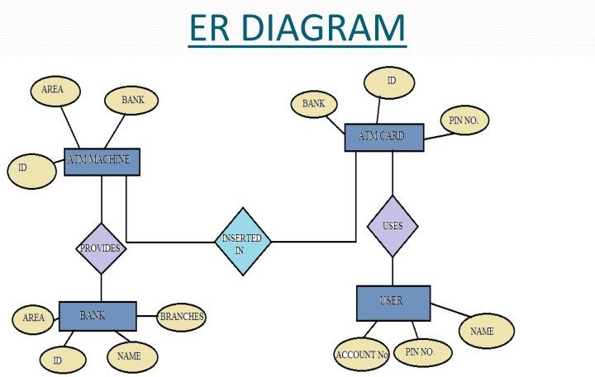

**Data flow Diagram:**

Level 0:

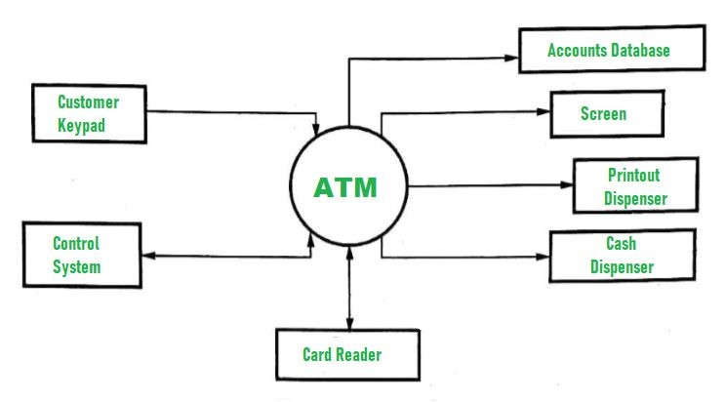

Level 1:

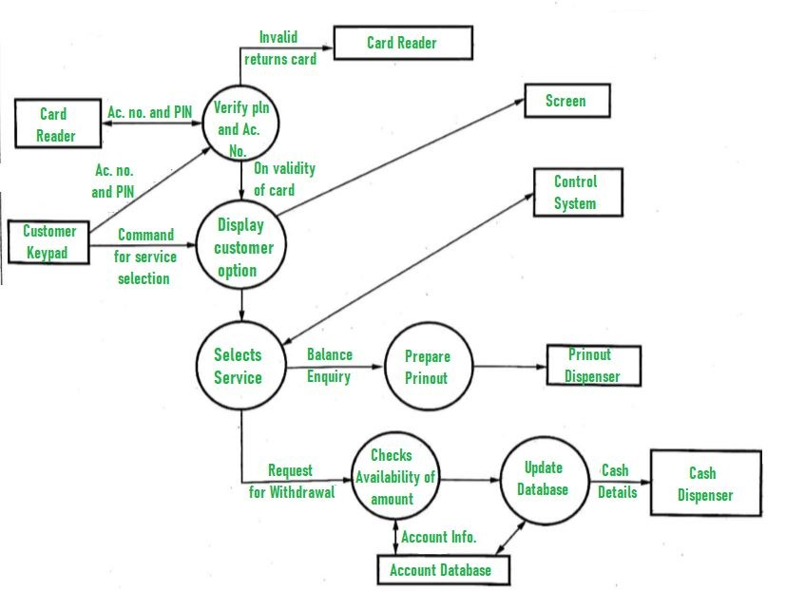

**UNL DESIGN**

**Use case Diagram:**

A use case diagram is a diagram which consists of set of usecases and actors enclosed by system boundary, and association between usecases and actors.  Usecases diagram especially important in organizing,  modeling the behavior of the system.

Use case is a set of scenarious tied together by a common user goal.  A scenario is a sequence of steps describing the interaction between a user and system.

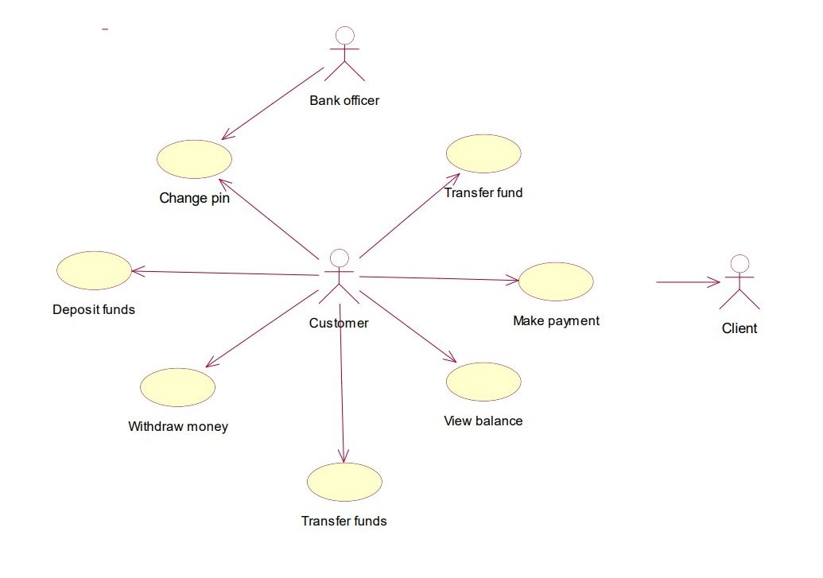

**Sequence Diagram:**

A sequence diagram is an easy way of describing the behavior of the system.  A sequence diagram shows an interaction arranged in time sequence.  It has two dimensions, the horizontal dimension represents the life of the object.

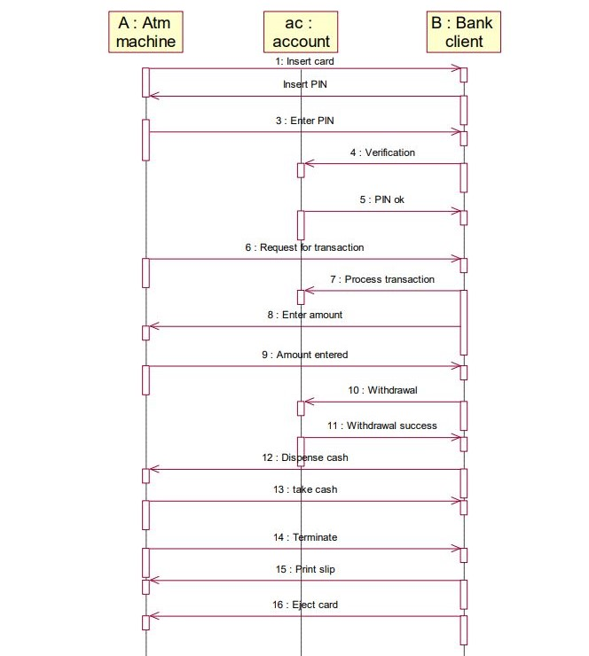

**Collaboration Diagram:**

Collaboration diagram represent a collaboration which is a set of objects related in a particular context and interaction which has asset of messages exchanges between objects.

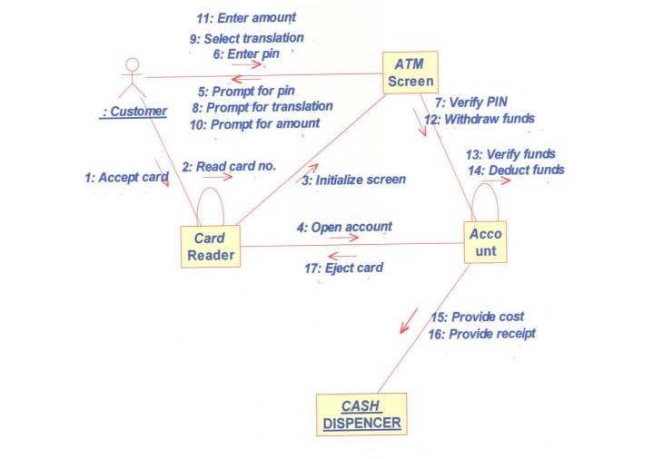

**Activity Diagram:**

This diagram describes the sequence of activities with superior for conditional and parallel behavior.

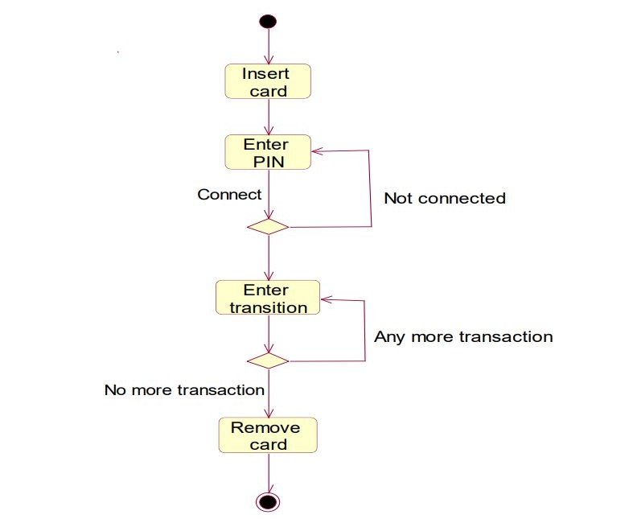

**Class Diagram:**

It describes that set of classed, interfaces and collaboration and their relationship.  It describes the types of objects in their system and various kinds of static relationship hat exceeds among them.

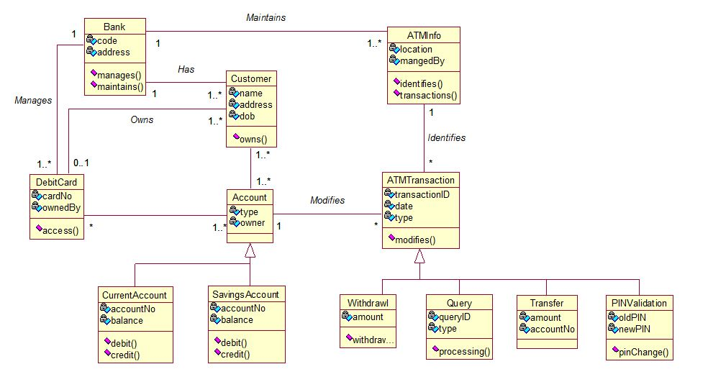

**Conclusion**

* From this report , one can observe that an ATM system is associated with the bank transactions of the consumers.
* Majorly, the ATM system is utilized for the money associated transactions from the consumers. Consumers make major use of ATM to withdraw money from their bank account.
* It is a fast way to get money out of your account, especially when on the go or during atrip .